

Name – Prashansa Raj
RegIstration Number – 25BAI10614

PROJECT NAME – SHOPPING LIST

INTRODUCTION –
The Shopping List Program is a beginner-friendly Python project designed to help users manage their daily shopping items. It uses basic programming concepts such as loops, lists, functions, and conditional statements. Through a simple text-based menu, the user can add items to their shopping list, remove items, view all the items currently stored, or exit the program. This project is ideal for learners who want to understand how user input works and how data can be stored and updated dynamically in Python.

PROBLEM STATEMENTS –
Managing daily shopping items can become difficult when the list keeps changing, and remembering all items is not always easy. There is a need for a simple program that allows users to store, update, and view their shopping items in an organized way. The goal is to create a Python program that:

Allows the user to add items to a shopping list

Allows the user to remove items from the list

Displays the current shopping list

Provides an easy-to-use menu-driven interface
Continues running until the user chooses to exit

This program should help users manage their shopping tasks efficiently using basic Python concepts like lists, loops, functions, and conditionals.

FUNCTIONAL AND NON-FUNCTIONAL REQUIREMENTS –
FUNCTIONAL RQUIREMENTS –
These are the features the program must perform:

1. Add Item - The system must allow the user to enter an item and add it to the shopping list.

2. Remove Item - The system must allow the user to remove a specific item if it exists in the list.
The system must show a message if the item is not found.

3. View Shopping List - The system must display all items currently added to the shopping list.
Items should be displayed with numbering for easier viewing.

4. Menu Display - The system must show a menu with options (Add, Remove, View, Exit) each time before asking for input.

5. User Input Handling - The program must accept the user’s choice and execute the corresponding function.
If the user enters an invalid option, the system must show an error message.

6. Exit Program - The program must terminate when the user selects the "Exit" option.
NON-FUNCTIONAL REQUIREMENTS –
These describe the quality and behavior of the program:

1. Usability - The program should be easy to understand for beginners.
The menu should be clear and user-friendly.

2. Reliability - The program should run continuously without crashing until the user chooses to exit.
The program should correctly handle invalid inputs.

3. Performance - All operations (add, remove, view) should execute instantly, since it is a small list-based program.

4. Maintainability - The code should be simple and structured using functions so it can be easily updated or expanded.

5. Portability - The program should run on any system that supports Python (Windows, macOS, Linux).

6. Efficiency - Memory use should be minimal as the program only stores a few items in a list.

SYSTEM ARCHITECTURE –
The system architecture of this Shopping List Program follows a simple linear and menu-driven architecture, where the user interacts with the program through inputs and the system processes those inputs to perform different tasks.

1. User Interface Layer - This is the layer where the user interacts with the program.
Shows the menu (Add, Remove, View, Exit)
Accepts user input for:
Menu choice
Item to add
Item to remove
This layer is completely text-based.

2. Application Logic Layer - This layer contains the core functioning of the program.

a) Menu Handling Logic
Displays menu
Takes user choice
Directs the flow to the correct operation (add/remove/view/exit)

b) Add Item Logic
Takes the item name from the user
Appends it to the list

c) Remove Item Logic
Checks whether the item exists in the list
Removes it if found
Shows an error message if not found

d) View List Logic
Checks if the list is empty
If not empty, displays all items with numbering
e) Exit Logic
Stops the loop and ends the program

3. Data Storage Layer - This program uses an in-memory data structure:
Python List (shopping_list)
This list serves as temporary storage where all items are kept until the program ends.

Architectural Flow(Simple Diagram Representation) –

+------------------------------+
| User Interface |
| (Menu + User Input) |
+--------------+---------------+
|
v
+------------------------------+
| Application Logic |
| - Add Item |
| - Remove Item |
| - View List |
| - Exit |
+--------------+---------------+
|
v
+------------------------------+
| Data Storage Layer |
| (shopping_list : Python List)
+------------------------------+

DESIGN DIAGRAM –
[Start]
|
v
[Show Menu]
|
v
[User Choice?]
|-------------------------------|-------------------------------|-------------------------------|
| | | |
v v v v
[Add Item] [Remove Item] [View List] [Exit Program]
| | | |
Input item → Append to list Input item → Check in list If list empty → Show msg Print "Goodbye"
Print confirmation If found → Remove Else → Display items End program
Else → Show error

DESIGN DECISIONS –
Design decisions explain why certain choices were made while building the program.
These decisions ensure that the program is simple, readable, and beginner-friendly.

1. Use of a Menu-Driven Approach
Decision: The program uses a repeating menu to let the user choose actions (Add, Remove, View, Exit).
Reason: Easy for beginners
Makes the program interactive
Clearly separates different functionalities

2. Use of a Python List for Storage
Decision: shopping_list = [] is used to store items.
Reason: Lists allow adding and removing items easily
No need for complex databases
Lightweight and fast for a small program

3. Using a While Loop for Continuous Execution
Decision: while True: keeps the program running until the user exits.
Reason: User can perform many operations without restarting the program
Makes the menu appear again automatically

4. Using a Function (show_menu())
Decision: A function is created to display the menu.
Reason: Avoids repeating code
Makes the code more organized
Improves readability and maintainability

5. String-Based User Input
Decision: Choices are handled as strings ("1", "2", "3", "4").
Reason: Prevents errors when converting input to integers
Easier for beginners to understand and use

6. Error Handling for Invalid Choice
Decision: Invalid menu choices show an error message.
Reason: Prevents program crashes
Improves user experience

7. Input Validation During Removal
Decision: Program checks if the item exists before removing it.
Reason: Avoids runtime errors
Ensures smooth functioning
Gives meaningful feedback to the user

8. Use of f-Strings for Output
Decision: print(f"{item} added to your shopping list.")
Reason: Cleaner and modern formatting style
Easier for beginners to understand

9. Text-Based Interface
Decision: The program uses a simple console interface, not GUI.
Reason: Simpler for learning
No need for external libraries
Works on all systems

IMPLEMENTATION DETAILS –
The program is implemented using basic Python concepts such as functions, loops, lists, and conditionals.
Below are the detailed steps explaining how each part of the code works.

1. Function Definition: show_menu()
def show_menu():
print("\n--- Shopping List Menu ---")
print("1. Add item")
print("2. Remove item")
print("3. View list")
print("4. Exit")

Explanation:
This function prints the menu every time the user needs to choose an option.
Using a function avoids repeating the same print statements multiple times.

2. Data Structure: shopping_list = []
A Python list is used to store all shopping items.
Lists allow:
Fast addition (append)
Easy removal (remove)
Iteration for viewing items

3. Infinite Loop for Continuous Execution
while True:

Explanation:
This loop keeps the program running until the user chooses to exit.
After each operation, the menu appears again.

4. Taking User Choice
choice = input("Enter your choice (1-4): ")

Explanation:
User enters a number as a string.
This choice determines which block of code will run.

5. Adding an Item
if choice == "1":
item = input("Enter item to add: ")
shopping_list.append(item)
print(f"✅ {item} added to your shopping list.")

Explanation:
Takes input item from the user
Adds it to the list using append()
Confirms addition with a message

6. Removing an Item
elif choice == "2":
item = input("Enter item to remove: ")
if item in shopping_list:
shopping_list.remove(item)
print(f"❌ {item} removed from your shopping list.")
else:
print("Item not found in the list.")

Explanation:
User enters the item to remove
Program checks if the item exists
Removes it using remove()
If not found, shows an error message
This prevents program crashes

7. Viewing the Shopping List
elif choice == "3":
if shopping_list:
print("\n🛒 Your Shopping List:")
for i, item in enumerate(shopping_list, start=1):
print(f"{i}. {item}")
else:
print("Your shopping list is empty.")

Explanation:
If list is not empty:
Displays each item with numbering using enumerate()
If empty:
Shows a message saying the list is empty

8. Exiting the Program
elif choice == "4":
print("Goodbye! 🛍")
break

Explanation:
break exits the while True loop
Program stops running

9. Handling Invalid Inputs
else:
print("Invalid choice. Please enter 1-4.")

Explanation:
If the user enters anything other than 1–4
Shows an error message without crashing the program

SCREENSHOTS/RESULTS –
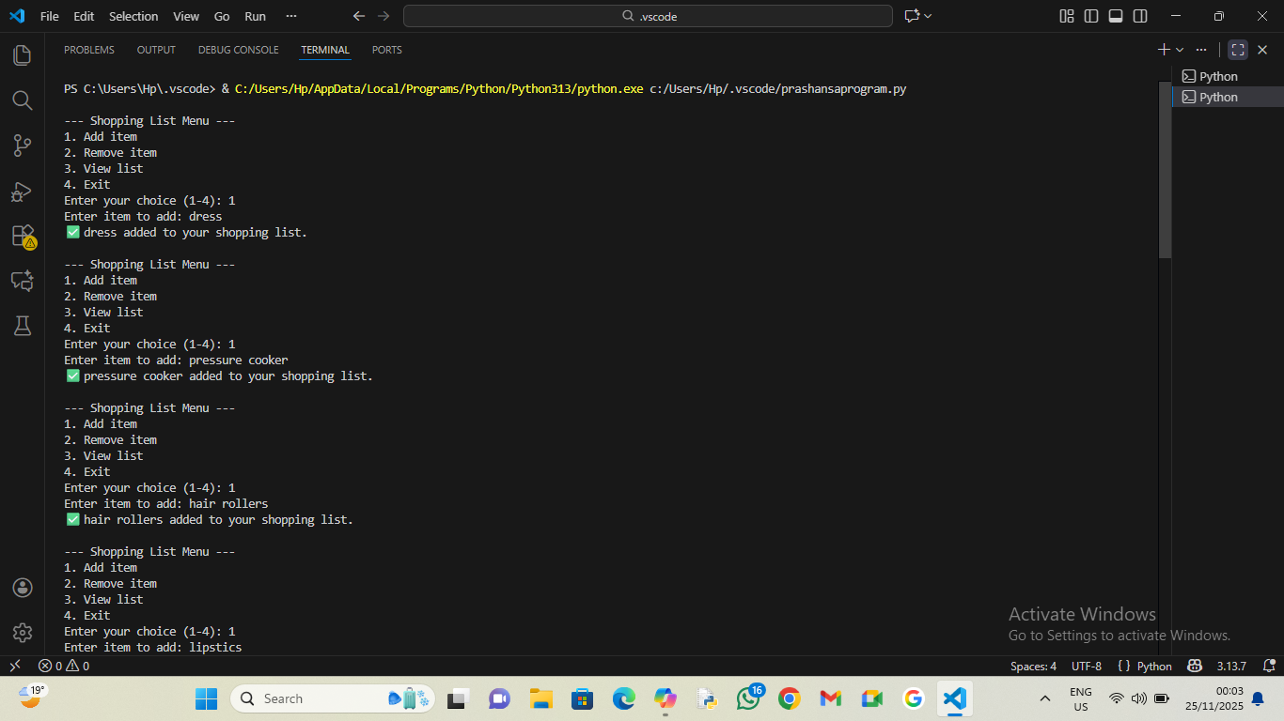
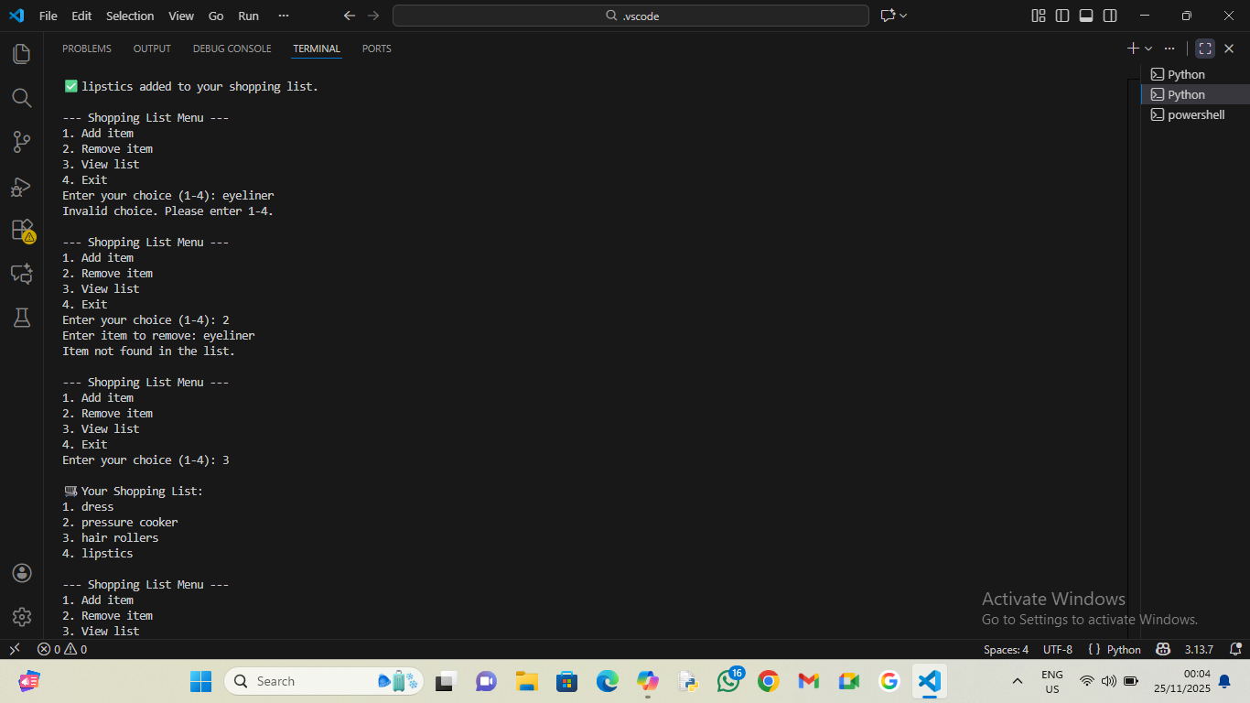
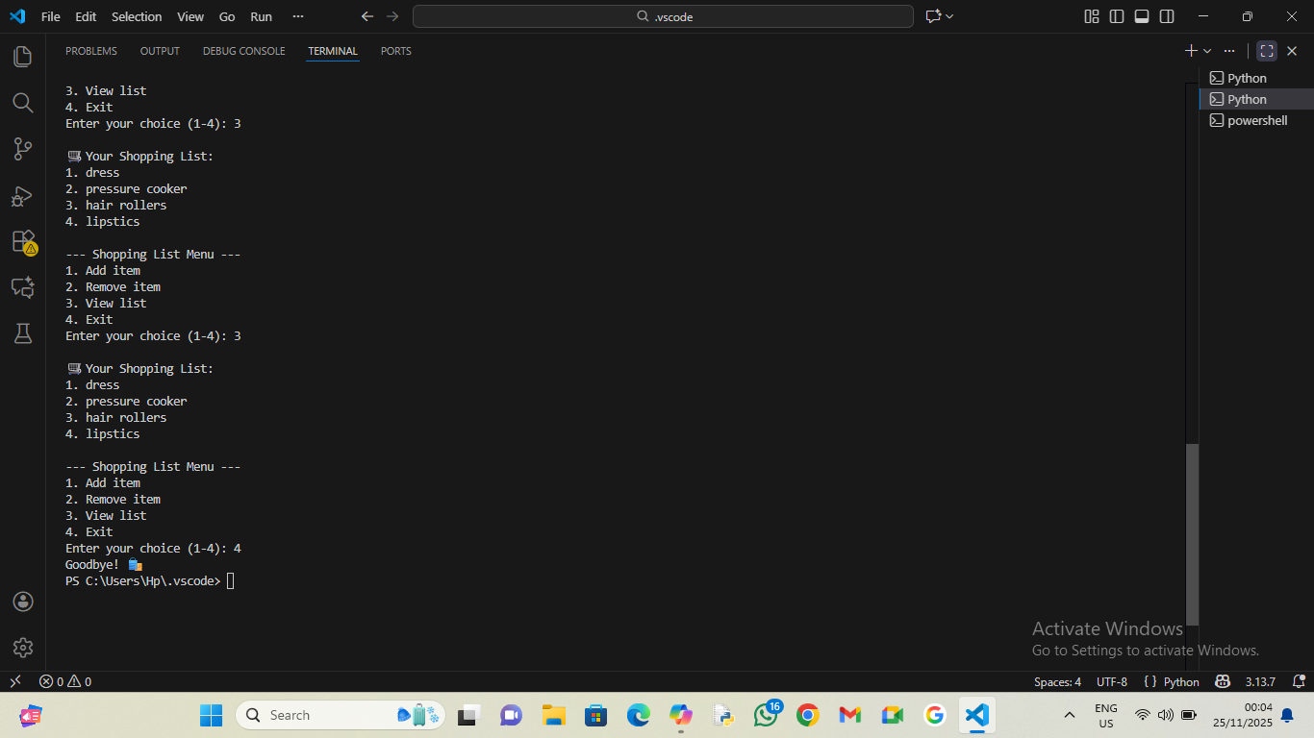

TESTING APPROACH –
The testing approach ensures that each feature of the program works correctly and handles all types of user inputs. Since this is a simple menu-driven Python program, manual testing is most suitable. The approach focuses on verifying functionality, user interaction, and error handling.

1. Functional Testing
This testing checks whether each option in the menu works correctly.

a) Add Item Test
Enter valid items (e.g., "Milk")
Enter multiple items
Verify they appear in the shopping list

b) Remove Item Test
Remove an item that exists
Try removing an item that does not exist
Check that the correct message appears

c) View List Test
View list after adding items
View list when list is empty
Check numbering and formatting

d) Exit Test
Select option "4"
Program should terminate cleanly

2. Input Validation Testing
Tests incorrect or unexpected user input.
Enter invalid menu options (e.g., "5", "abc", special characters)
Verify program shows: “Invalid choice”
Try removing without adding items
Enter empty strings as item names
Program should not crash

3. Negative Testing
Checks how the system behaves with wrong or unusual inputs.
Try removing an item from an empty list
Try adding very long item names
Enter same item multiple times
Remove an item that appears multiple times (only first occurrence should be removed)

4. Usability Testing
Ensures the program is easy to use.
Verify menu is clearly displayed each time
Check confirmation messages:
“added”
“removed”
“not found”
Validate that the flow is simple and understandable for beginners

5. Performance Testing (Basic)
Even though the program is small, basic checks can be done:
Add large number of items (50–100)
View the list
Remove items
Program should still respond instantly

6. Loop and Flow Testing
Checks the continuous execution of the program.
Perform a sequence like:
1. Add item
2. Add item
3. View
4. Remove
5. Invalid choice
6. View
7. Exit
Ensure the loop behaves correctly and returns to menu after every action

7. Boundary Testing
Checks extreme or edge conditions.
Add the first item (boundary of empty → non-empty)
Remove the last item (boundary of 1 → 0 items)
Enter choice as “1 “ (with space) or “ 2”

CHALLENGE FACED –
Although the program is simple, several small challenges can occur during development and testing:

1. Input Validation Issues
One challenge was ensuring the program handled invalid inputs, such as:
Entering letters instead of numbers for menu choices
Entering blank inputs
Entering items that don’t exist in the list
The solution was to add checks and proper error messages.

2. Preventing Program Crashes During Removal
If the user tried removing an item that was not in the list, Python would normally give an error.
To avoid this, the condition:
if item in shopping_list:
had to be added.
This required extra logic to keep the program stable.

3. Maintaining Continuous Menu Flow
The program needed to:
Show the menu again after every action
Keep running until “Exit” is chosen
Using while True: solved the problem, but careful placement of break was needed to avoid accidental infinite loops or early exit.

4. Keeping Output Clear and User-Friendly
Designing simple and clear messages for:
Adding items
Removing items
Viewing list
Invalid choices
was important because confusing messages could mislead users.

5. Avoiding Repetition in Menu Display
At first, the menu lines were repeated in multiple places.
To solve this, the menu was moved into a function (show_menu()).
This improved readability and reduced duplication.

6. Handling Duplicate Items
If the same item was added twice:
Removing it removed only the first occurrence
This behavior had to be explained or accepted since Python’s remove() works that way.

7. Designing a Simple but Effective Architecture
Although small, the program still needed:
A UI layer
Logic layer
Storage layer
Ensuring these remained clean and separate was a challenge while keeping the code beginner-friendly.

LEARNINGS –
Developing this program provided several important programming and logical thinking skills. Here are the key learnings:

1. Understanding of Python Lists

You learn how to:
Add items using append()
Remove items using remove()
Check if an item exists
Loop through all items
Lists become clear as a fundamental data structure.

2. Use of Functions for Better Structure
Creating show_menu() shows why functions are useful:
Reduces repeated code
Makes the program more organized
Improves readability

3. Handling User Input
You learn how to:
Accept user input using input()
Convert or compare input values
Handle unexpected or invalid inputs
This improves interactive program skills.

4. Decision Making with Conditional Statements
You learn how to apply:
if, elif, and else
Choosing actions based on user choices
Validating conditions before processing
This builds logic and flow control understanding.

5. Working with Infinite Loops
Using while True: teaches:
How to keep a program running
How to stop loops using break
How to design menu-driven applications
This is essential for many console-based programs.

6. Error Handling Through Logic
You learn to prevent crashes by:
Checking item existence before removal
Showing appropriate messages for wrong inputs
This develops stable and user-friendly programming.

7. Structuring a Menu-Driven Program
You understand how to:
Display menus
Take choices
Run functions accordingly
This is a common pattern in beginner projects.

8. Improving User Experience (UX) in Coding
You learn how important it is to:
Print clear and meaningful messages
Guide the user properly
Keep interfaces simple
Even console programs need good UX.

9. Building a Small Real-Life Application
You realize how simple code can solve real tasks like:
Maintaining shopping lists
Managing daily items
Creating basic productivity tools
This boosts confidence in applying Python practically.

FUTURE ENHANCEMENTS –
Although the current version works well for basic operations, many improvements can be added to make the program more powerful, user-friendly, and practical. Here are some possible enhancements:

1. Save and Load Shopping List to File
Store the list in a text file, JSON file, or CSV file
Load the list automatically when the program starts
Prevents data loss after exiting the program

2. Add Quantity for Each Item
Instead of just item names, users can enter:
Item
Quantity (e.g., 2 kg, 5 packets)
This makes the list more detailed and useful.

3. Add Categories
Items can be grouped into categories like:
Fruits
Vegetables
Dairy
Household items
This helps organize the list better.

4. Search Feature
Allow the user to search for an item in the list:
Shows whether the item exists
Shows its index or category

5. Edit or Update an Item
Instead of just removing, users can:
Rename an item
Update its quantity or category

6. Prevent Duplicate Entries
Add logic to avoid adding the same item twice:
Show message: "Item already exists"

7. Create a Graphical User Interface (GUI)
Using:
Tkinter
PyQt
Kivy
This will make the program more user-friendly and professional.

8. Export List to PDF or Excel
Users can export the final shopping list for printing or sharing.

9. Add Login or User Profiles
Multiple users can maintain:
Their own shopping list
Saved lists
Personalized features

10. Add Voice Input (Speech Recognition)
User can say:
“Add milk”
“Remove sugar”
“Show my list”
This improves accessibility.

11. Add Sorting Options
Sort items:
Alphabetically
By category
By quantity

12. Add Notification or Reminder System
Remind users of items they frequently forget
Notify if a list has items older than a week

REFRENCES –
1. Python Official Documentation
Python Software Foundation. Python Documentation – Built-in Types, Functions, and Control Flow.
https://docs.python.org/

2. W3Schools – Python Tutorial
W3Schools. Python Lists, Loops, Input/Output, and Functions.
https://www.w3schools.com/python/

3. GeeksforGeeks – Python Programming
GeeksforGeeks. Menu-driven programs, list operations, and beginner-level Python examples.
https://www.geeksforgeeks.org/python-programming-language/

4. TutorialsPoint – Python Basics
TutorialsPoint. Understanding Python lists, loops, and functions for beginner programs.
https://www.tutorialspoint.com/python/index.htm

5. Stack Overflow Community Discussions
Stack Overflow. General Python coding practices and troubleshooting help.
https://stackoverflow.com/

6. Class Notes / Lab Manual (if applicable)
Your institution’s class notes and lab guides for Python basics, input handling, and list manipulation.

